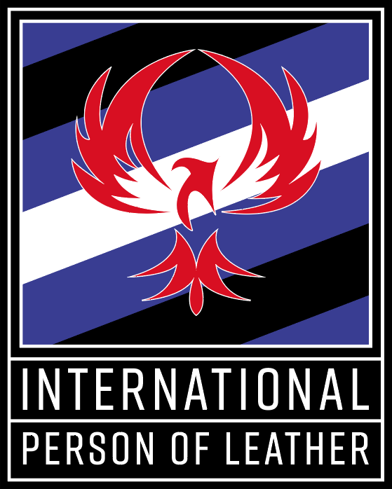

International Petition
International Person of Leather Contest
Owned and Produced by South Plains Leatherfest

(Last update: 6/8/2025)

Basic Philosophy for the International Person of Leather Contest and Titles

International Person of Leather will be selected not based on gender identity, sexual orientation, race, physical appearance, age, or disability, but rather on their ability to articulate their views, passions, and dedications and to make an impact in their communities. We will expect these People of Leather to act as mentors, educators, role models and spokespeople throughout their title year. The International Person of Leather Contest is a celebration of the diversity in the Leather community. The title of Person of Leather exists to promote that diversity.

Eligibility of International Contestants to Compete at the International Person of Leather Contest
International invites and encourages contestants from outside of the United States (“international contestants”) pursuant to the following rules and policies:

- The decision to accept any international contestant by Petition to compete at the International Person of Leather Contest (“International”) in any given year is completely within the discretion and control of the Owner/Producer of International.

- All contestants competing in the International Person of Leather Contest must be at least 21 years of age, self-identify as part of the Leather Community and have participated in the Leather Community for at least five years prior to competing for the International Person of Leather title.

- Process of Petitioning to International

- All contestants who live outside of the United States may petition directly to International to compete in the International Person of Leather Contest.

Contestants in the Countries of Canada or Mexico have an additional option to obtain eligibility to compete at the International Person of Leather Contest.

Contestants who live in Canada or Mexico may either petition International directly to compete or choose to compete at a United States Regional Feeder Contest as follows:

- British Columbia and Alberta may choose to run in the IPOL Northwest Region.
- Saskatchewan, Manitoba, north of Manitoba, Yukon and the Territories may choose to run in the IPOL Rocky Mountain Region.
- Ontario and east of Ontario may choose to run in the IPOL Northeast Region.

Contestants who live in Mexico may either petition International directly to compete in the International POL Contest or if they desire support from a U.S. Regional Contest and Organization, they may compete in and win the U.S. Southwest Regional contest.

An international contestant is not required to go through a contest or other selection process in order to submit a Petition to Compete at International. However, it is the opinion of the Owner/Producer of International that going through a contest process similar to the process used at International is helpful to the contestant as part of their preparation to run for the International title.

- The international contestant must submit an International Contestant Petition to Compete (“Petition”) no later than October 1st prior to the International Contest however in any given year, an international contestant may be accepted prior to October 1st. (For example, an international contestant wishing to compete at International 2025 would need to submit a Petition no later than October 1, 2024.) International contestants who petition to compete will be notified of International’s decision on their Petitions no later than October 15th. In a given year, an International contestant may be accepted prior to the October 1st deadline. Only one international contestant will be selected each year.

- If an international contestant’s Petition is accepted, the contestant will be required to follow the same International rules as a Regional contestants, including submitting the formal IPOL Contestant Application. All contestants will be judged according to the IPOL Judges’ Handbook and will be subject to the rules and requirements found in the Judges’ Handbook, the IPOL Contest Application, the IPOL Contest Handbook and the IPOL Contest Regional Handbook. These documents are available at the South Plains website (www.southplainsleatherfest.com)

- An international contestant must agree that during the time period between the date they submit their petition to International and the date of the International Person of Leather Contest, they will not engage in interviews with or appear in “vanilla” mainstream media (whether print, television, film, radio or internet based) without the express written consent of the Owner/Producer of the International Person of Leather Contest.

- If the Petition of an international contestant is not accepted by International, they may re-petition International for the opportunity to compete in a future year. An international contestant may not petition to compete at International more than two (2) times.

- If the Petition of an international contestant is accepted by International but the contestant does not win at International, they may re-petition International for the opportunity to compete in a future year. An international contestant may not petition to compete at International more than two (2) times.

- If an international contestant competes and wins the International contest they are not eligible to petition or to compete at International in any subsequent year.

- It will be the responsibility of an international contestant competing at International to obtain all travel documents, visas, clearances, etc. needed in order to enter the United States. Because of the privacy sensitivities and issues that still impact the Kink and Leather community in the U.S., an international contestant should not highlight the International contest or South Plains Leatherfest as the reason for entering the country.

- The official language of the International contest is English. If a contestant believes they need an interpreter to effectively compete at International, they may bring one at their own expense. South Plains Leatherfest will provide the interpreter with a basic weekend package.

- Prior to submitting a Petition, an international contestant should carefully read the IPOL Judges’ Handbook, the IPOL Handbook and the formal IPOL Contestant Application, all of which are available at the South Plains website (www.southplainsleatherfest.com).

- If an international contestant wins International, the titleholder will be expected to meet the requirements for the title as stated in the Contestant Application. The titleholders are required to attend a minimum number of events each year; these events do not have to be in the United States.

Petition to Compete at the
International Person of Leather Contest

Petition is due by October 1st

Please return a scanned electronic signed copy of the completed Petition to Tomo.SPLF@gmail.com.
Use as much space as needed.)

The year of contest you are petitioning to compete in:

Legal Name:

Scene Name (if any):

Pronouns: Gender Identity:

Date of Birth:

FetLife, Facebook or other BDSM Social Networking Site Names (if any):

Address:

City: State/Province:

Country: Postal Code:

Phone:

Email(s):

Club or group affiliations:

Previous Titles Held:

Time in the Leather Community:

Describe your personality:

Leather/Kink Community service work:

Why do you want the opportunity to run for International Person of Leather:

BDSM/Leather events attended in the past year – please provide name of the event, location, a brief description of the event and approximate number of attendees.

How did you find out about the International Person of Leather?

Describe the Leather and Kink community in your home country (is it well developed, newly forming, etc.) and how your participation as contestants in the International Person of Leather Contest would benefit your home community.

If you ran for and won the International Person of Leather title, how would you as a titleholder living outside of the United States maintain a presence at U.S. based events, including the IPOL Regional contests and events as well as events outside of the United States?

Have you ever been convicted of a felony in the U.S. or any criminal act in another country that would be the equivalent of a felony crime in the U.S.? [Please note: The decision as to whether a felony conviction or its equivalent will disqualify a contestant from competing for the IPOL Title is solely within the discretion and judgment of the Owner of IPOL.]

Have you ever been accused of a consent violation, abuse, or any other violation in the community? [Please note: The decision as to whether an accusation of a community violation will disqualify a contestant from competing for the IPOL Title is solely within the discretion and judgment of the Owner of the IPOL Title System.]
Yes _______ (Please provide details below.)
No _______

Any additional information you would like the Owner/Producer of IPOL to know?

DISCLAIMER AND RELEASE OF LIABILITY: In consideration of the acceptance of our Petition herewith by the Owner and Producer of South Plains Leatherfest and the International Person of Leather Title and Contest, by completing this Petition we hereby waive, release and forever discharge South Plains, L.L.C., South Plains Leatherfest, its owners, producers, members, agents, operators, employees, lessors, lessees, parent companies or entities, affiliated companies or entities, representatives or subsidiaries from any and all demands, actions, causes of actions, claims of injury or damage to our persons, property or reputations, costs, damages, expenses, attorney’s fees or penalties of any kind or nature, whether asserted or unasserted, known or unknown, that may arise now or in the future from any cause whatsoever in connection with our participation in and with the International Person of Leather Contest and South Plains Leatherfest. We hereby give permission for the use of our scene names in connection with publicity for South Plains Leatherfest and the International Person of Leather title and contest. By completing this Petition, we hereby state that we have read and understand the above disclaimer. We further state that each of us is at least 21 years of age.

Signature of Petitioner: ________________________________ Date: ___________________

